MultiLevel Inheritance Program in Java

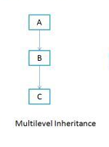

class Car{
public Car()
{
System.out.println("Class Car");
}
public void vehicleType()
{
System.out.println("Vehicle Type: Car");
}
}
class Maruti extends Car{
public Maruti()
{
System.out.println("Class Maruti");
}
public void brand()
{
System.out.println("Brand: Maruti");
}
public void speed()
{
System.out.println("Max: 90Kmph");
}
}
public class Maruti800 extends Maruti{

public Maruti800()
{
System.out.println("Maruti Model: 800");
}
public void speed()
{
System.out.println("Max: 80Kmph");
}
public static void main(String args[])
{
Maruti800 obj=new Maruti800();
obj.vehicleType();
obj.brand();
obj.speed();
}
}

Class: Account
Cust_name , acc_no
Class: Saving_Acc
Min_bal, saving_bal
Class:Acct_Details
Deposits, withdrawals

import java.lang.*;
import java.io.*;
class Account
{
String cust_name;
int acc_no;
Account(String a, int b)
{
cust_name=a;
acc_no=b;
}
void display()
{
System.out.println ("Customer Name: "+cust_name);
System.out.println ("Account No: "+acc_no);
}
}
class Saving_Acc extends Account
{
int min_bal,saving_bal;
Saving_Acc(String a, int b, int c, int d)
{
super(a,b);
min_bal=c;
saving_bal=d;
}
void display()
{
super.display();
System.out.println ("Minimum Balance: "+min_bal);
System.out.println ("Saving Balance: "+saving_bal);
}
}
class Acct_Details extends Saving_Acc
{
int deposits, withdrawals;
Acct_Details(String a, int b, int c, int d, int e, int f)
{
super(a,b,c,d);
deposits=e;
withdrawals=f;
}
void display()
{
super.display();
System.out.println ("Deposit: "+deposits);
System.out.println ("Withdrawals: "+withdrawals);
}
}
class q9Multilevel
{
public static void main(String args[])
{
Acct_Details A = new Acct_Details("Pa.one",666,1000,5000,500,9000);
A.display();
}
}

Hybrid Inheritance in Java

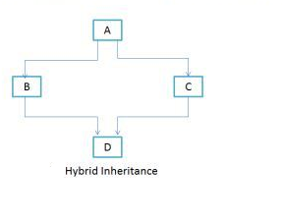

interface A
{
public void methodA();
}
interface B extends A
{
public void methodB();
}
interface C extends A
{
public void methodC();
}
class D implements B, C
{
public void methodA()
{
System.out.println("MethodA");
}
public void methodB()
{
System.out.println("MethodB");
}
public void methodC()
{
System.out.println("MethodC");
}
public static void main(String args[])
{
D obj1= new D();
obj1.methodA();
obj1.methodB();
obj1.methodC();
}
}

Example

class a
{
int i,j;
void show()
{
System.out.println("value of i is"+i);
System.out.println("value of j is"+j);
}
}
class b extends a
{
void sum()
{
int k=i+j;
System.out.println("value of k is "+k);
}
}
class c extends a
{
void fact()
{ int j=1;
for(int a=1;a<=i;a++)
{
j=j*a;
}
System.out.println(j);
}
}
class Final extends c
{
public static void main(String arg[])
{
a obj=new a();
obj.i=10;
obj.j=20;
obj.show();
b obj1=new b();
obj1.i=100;
obj1.j=200;
obj1.sum();
c obj2=new c();
obj2.i=5;
obj2.fact();
}
}

Hierarchical Inheritance

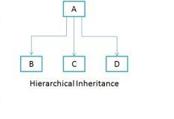
Class A
{
public void methodA()
{
System.out.println("method of Class A");
}
}
Class B extends A
{
public void methodB()
{
System.out.println("method of Class B");
}
}
Class C extends A
{
public void methodC()
{
System.out.println("method of Class C");
}
}
Class D extends A
{
public void methodD()
{
System.out.println("method of Class D");
}
}
Class MyClass
{
public void methodB()
{
System.out.println("method of Class B");
}
public static void main(String args[])
{
B obj1 = new B();
C obj2 = new C();
D obj3 = new D();
obj1.methodA();
obj2.methodA();
obj3.methodA();
}
}

